Hostel Management System

UCS503 Software Engineering Project Report

End-Semester Evaluation

Submitted by:

102083032 Aviral Batra (Offline)

101903483 Shashwat Garg (Offline)

101903089 Prabhnoor Kaur (Offline)

BE Third Year, COE

Group No: COE19

Submitted to:

Arwinder Dhillon



Computer Science and Engineering Department TIET, Patiala

October 2021

**TABLE OF CONTENTS**

### Project Selection Phase

* 1. Software Bid
  2. Project Overview

### Analysis Phase

* 1. Use Cases
     1. Use-Case Diagrams
     2. Use Case Templates
  2. Activity Diagram and Swimlane Diagrams
  3. Data Flow Diagrams (DFDs)
     1. DFD Level 0
     2. DFD Level 1

2.3.3 DFD Level 2

* 1. Software Requirement Specification in IEEE Format

### Design Phase

* 1. Class Diagram
  2. Sequence Diagram
  3. Collaboration Diagram
  4. Database Design: ER Diagram

3.5 State Chart Diagrams

### Implementation

* 1. Component Diagrams
  2. Deployment Diagrams
  3. Screenshots

### Testing

* 1. Test Plan
  2. Test Cases
  3. Test Report

1. Project Selection Phase

1.1 Software Bid

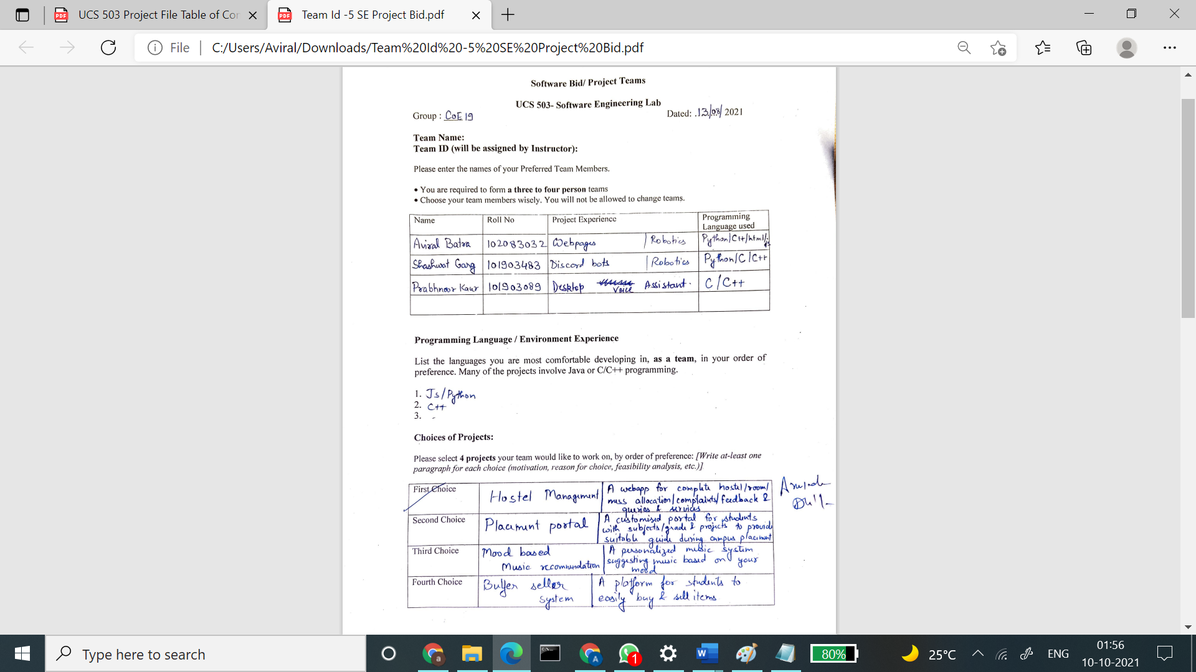

1.2 Project Overview

The product will run as a website wherein when the concerned person opens the website's home page, and the person will be asked to log in. Admin, itself will create the user. Once they log in, a prompt will appear. They will have Multiple Options, including Selecting a Room, Housekeeping, electrical maintenance, AC repair, carpentry work, plumbing issue, mess feedback, and others. In-room selection, you can Select a room of your choice. For Housekeeping, you can send the request with the desired time, cleaning Staff will be allocated. In the Complaint, a box will appear where the student can type the Complaint by selecting the type of Complaint. The notification will go to the admin as well as concerned Staff.

2. Analysis Phase

2.1 Use Cases

2.1.1 Use-Case Diagrams

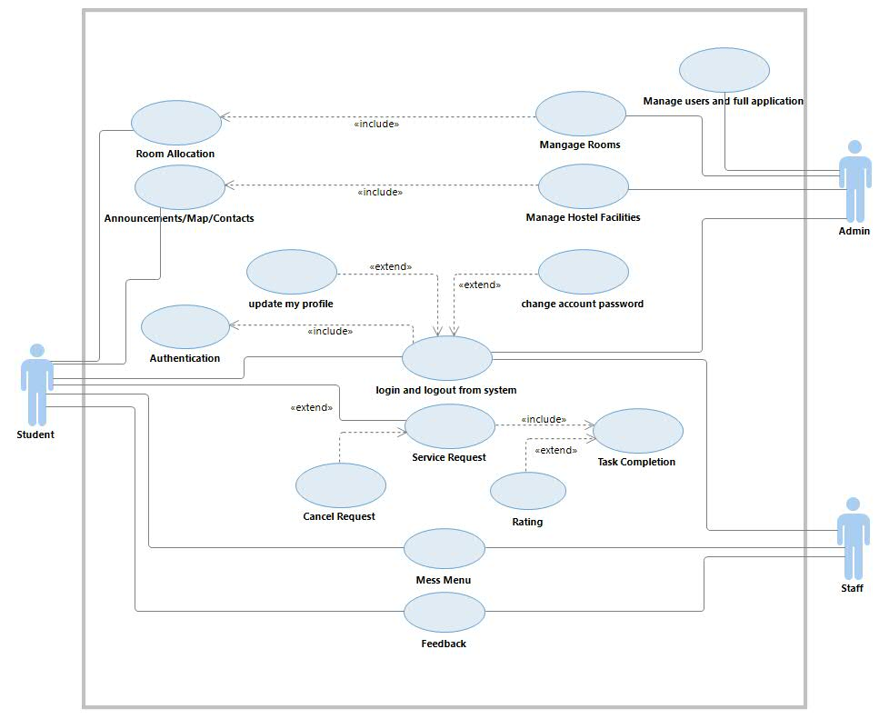

Figure 1 Use-Case Diagram

Figure 1 shows use case diagram. It is used to represent the dynamic behavior of a system. It encapsulates the system's functionality by incorporating use cases, actors, and their relationships. Actor here are student who can request for services after room allotment, Admin who is in charge of room allocation and various crucial tasks and Staff who handles mess menu.

2.1.2 Use Case Templates

|  |  |
| --- | --- |
| Use Case ID | UC01 |
| Use Case Name | Login Users |
| Actor(s) | Username, Staff |
| Description | User selects the Login option and fills correct login details. |
| Pre-Conditions | User must be registered |
| Task Sequence | 1. Click on the Login option.  2. Enter the required information.  3. On clicking the submit button, the user will be Logged in successfully. |
| Post-conditions | 1. User Logged in Successfully  2. Invalid Information. |
| Success Scenario | User is Logged in successfully. |
| Special Requirement | User must be registered and rest all the details must be correct. |

|  |  |
| --- | --- |
| Use Case ID | UC02 |
| Use Case Name | Room Allocation |
| Actor | Student, Admin |
| Description | The administrator will view the applications from Database. The admin will manage and assign rooms based on the information provided in the application. |
| Pre-Conditions | Admin must select manage and then choose the application-information database option. |
| Task Sequence | 1. Admin will view the applications from application-info database.  2. Admin will allot the hostel and room basis on provided info.  3. Admin will update the allotted hostel and room on user application. |
| Post Conditions | 1. Update made by admin is performed successfully.  2. Update made by admin is not performed successfully. |
| Success Scenario | Rooms are successfully allotted by admin. |
| Special Requirement | Correct admin id and password. |

|  |  |
| --- | --- |
| Use Case ID | UC03 |
| Use Case Name | View and service the request. |
| Actor | Student, Staff |
| Description | The staff will view the request and will take the desire action. |
| Pre-Conditions | Only those requests that staff can fulfil should be made. |
| Task Sequence | 1. Staff will view the request.  2. Staff will service the request.  3. A pending feedback will be sent to user. |
| Post-Conditions | 1. Request will be serviced.  2. Request will not be serviced. |
| Success Scenario | Pending feedback is sent to user successfully. |
| Special Requirement | Must have valid request. |

2.2 Activity diagram and Swimlane Diagrams

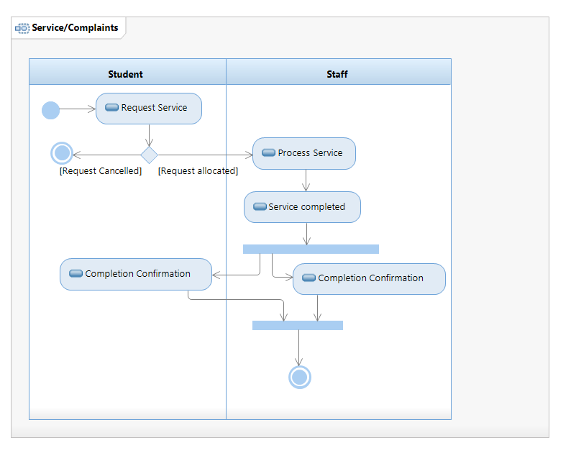

Figure 2 Activity and Swimlane Diagram

Figure 2 shows the Activity diagram for our hostel management system. Activity diagram shows the flow of activities that goes while accessing and using the software. After authentication, student can request for service such as room allocation and other services which will be handled by admin and staff. Admin can see all the student records and will handles the request by students.

2.3 Data Flow Diagrams (DFDs)

2.3.1 DFD Level 0

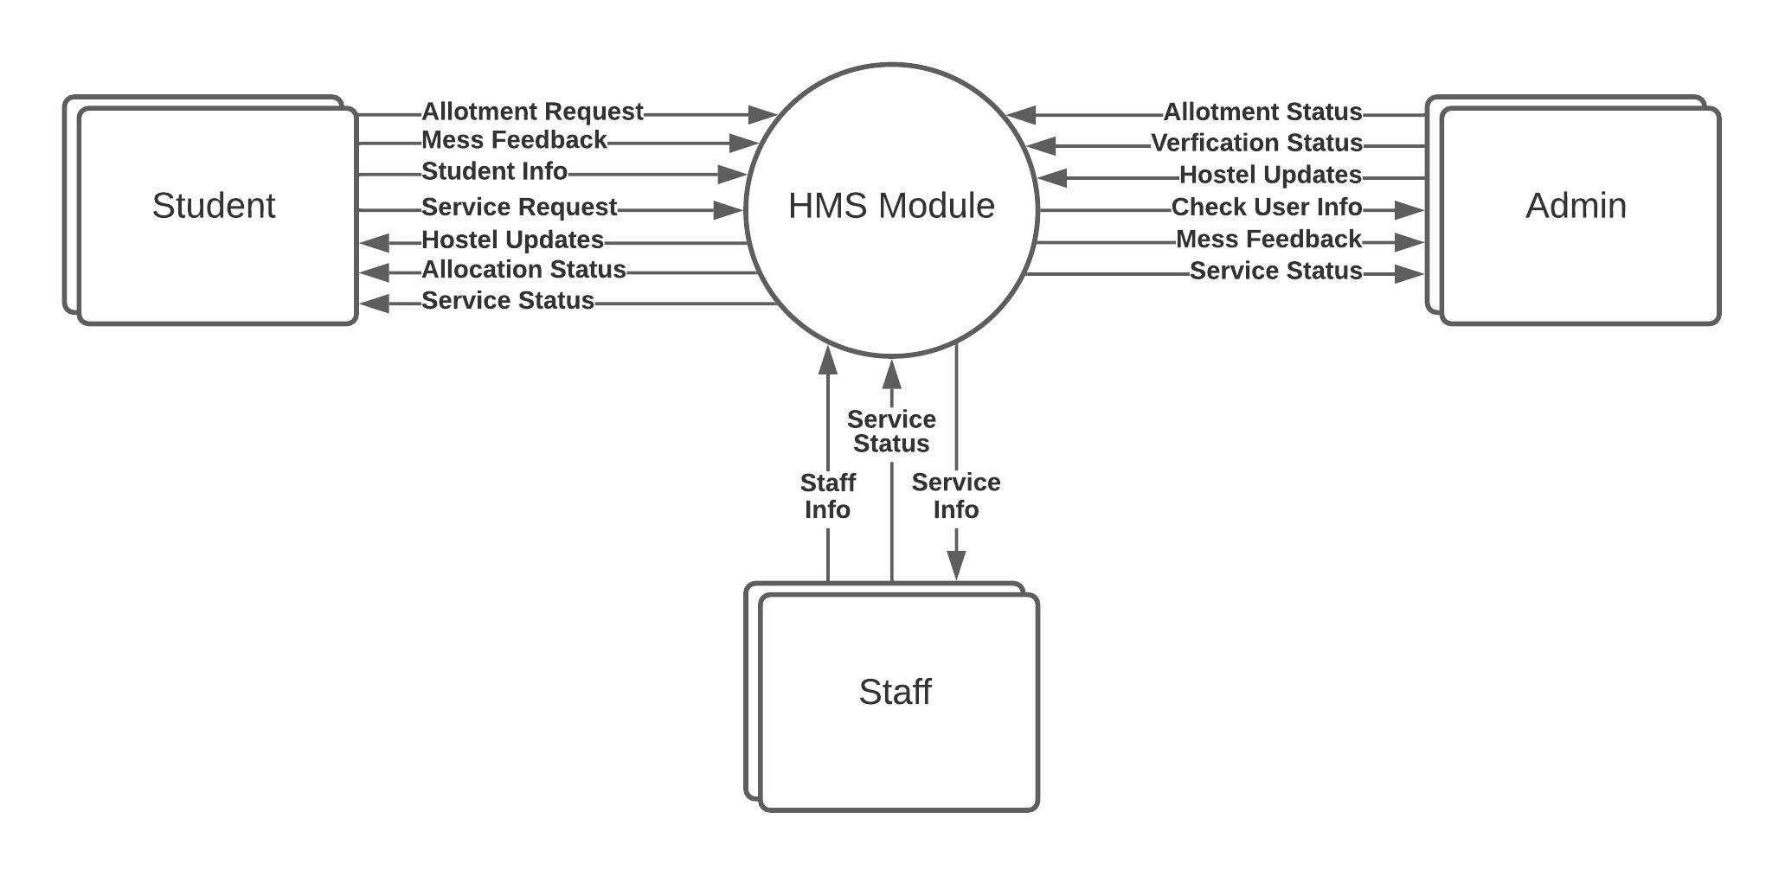

Figure 3.1 DFD Level 0

Figure 3.1 shows the Data Flow Diagram of the HMS. This is the 0 level Data Flow Diagram which gives an overview about the information provided by the external entities, i.e., students, staff and the admin to the module, and what information they receive back.

2.3.2 DFD Level 1

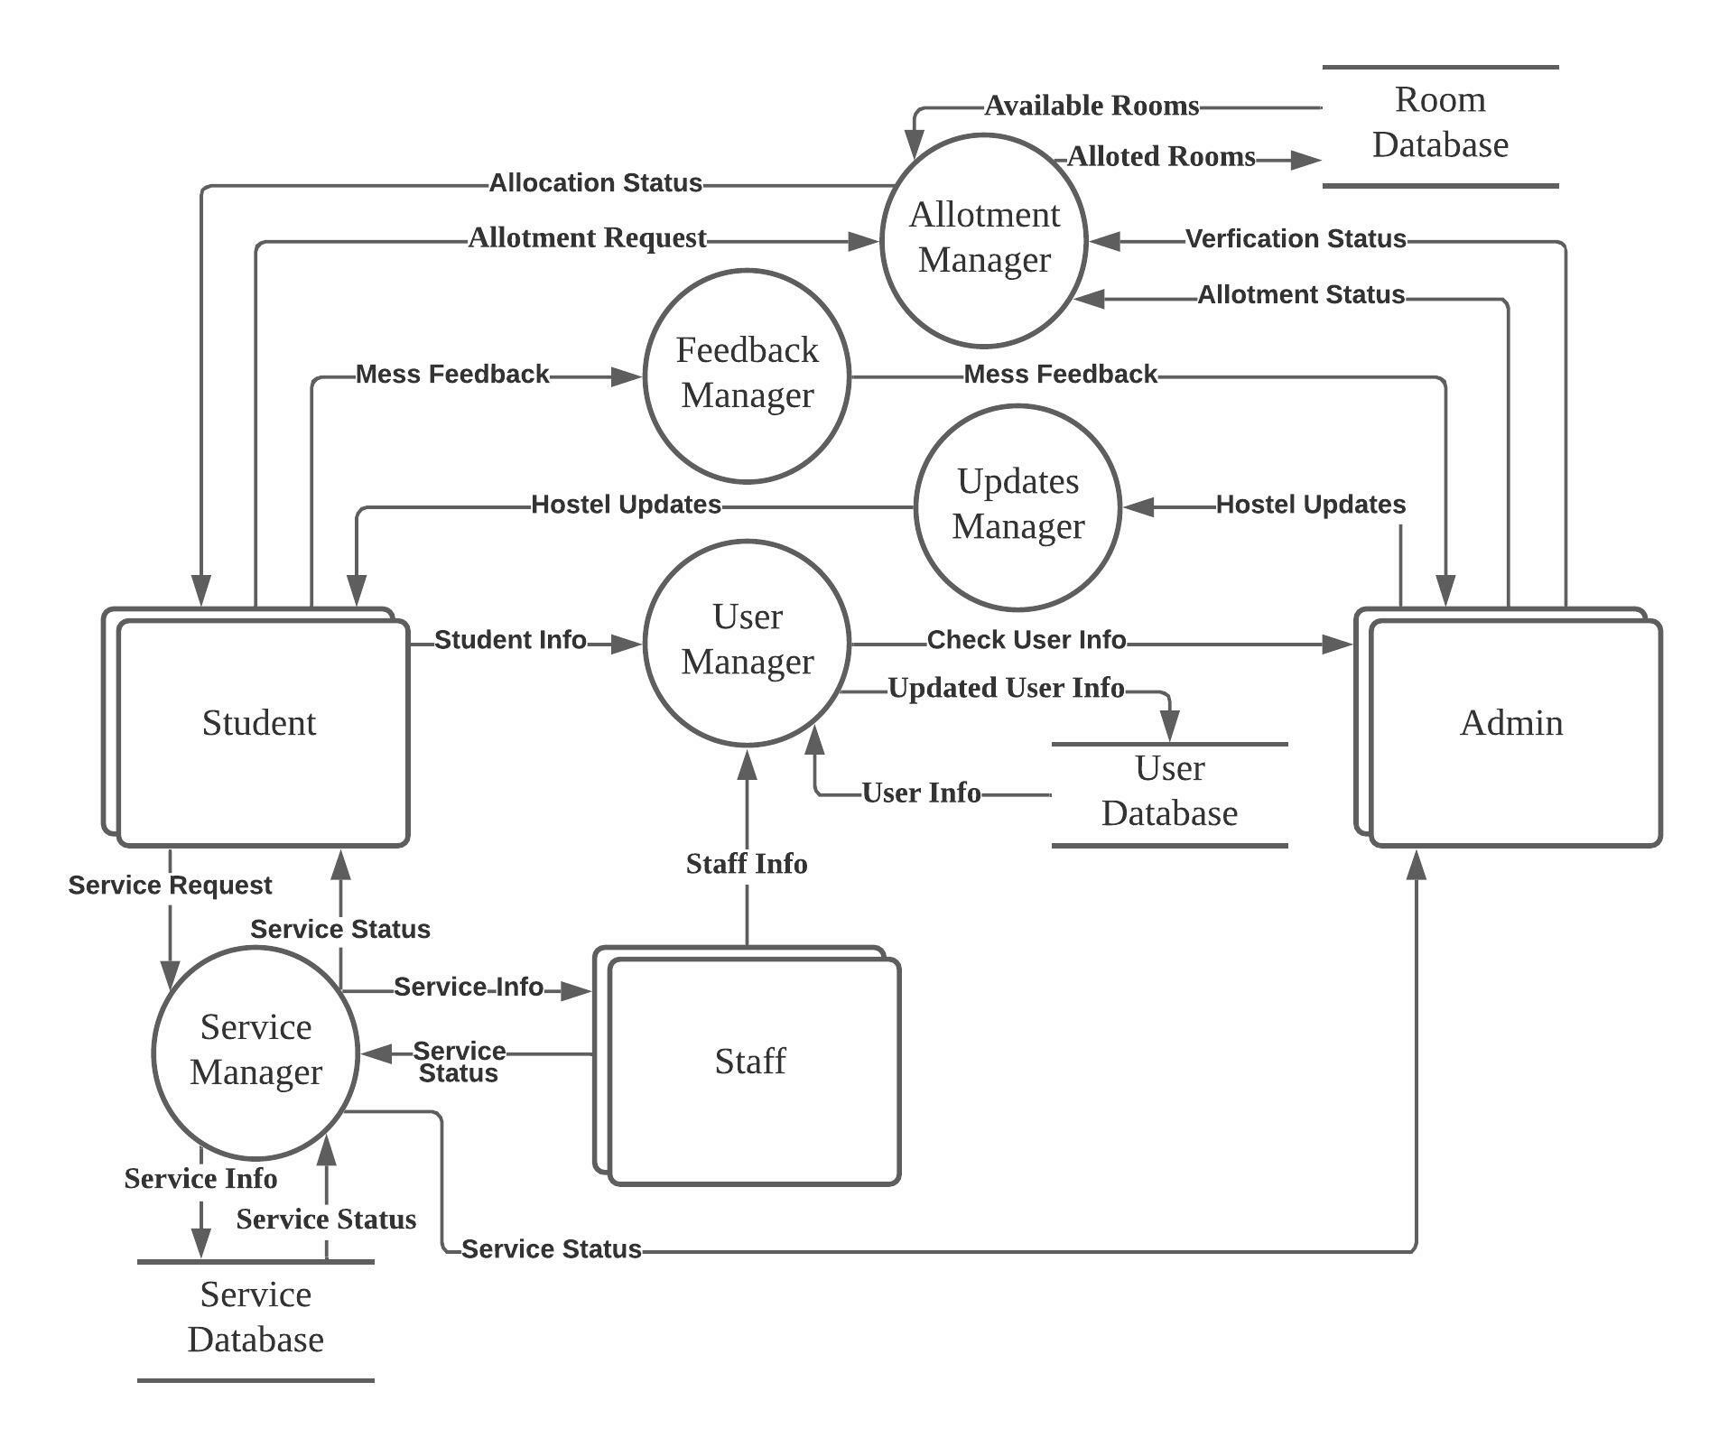

Figure 3.2 DFD Level 1

Figure 3.2 is the level 1 Data flow diagram. It basically represents the flow of data in the portal. It explains all the processes happening in the portal to that together form the complete system. We can think of a level 1 DFD as an “exploded view” of the context diagram. This figure also shows the databases where the data is stored.

2.3.2 DFD Level 2

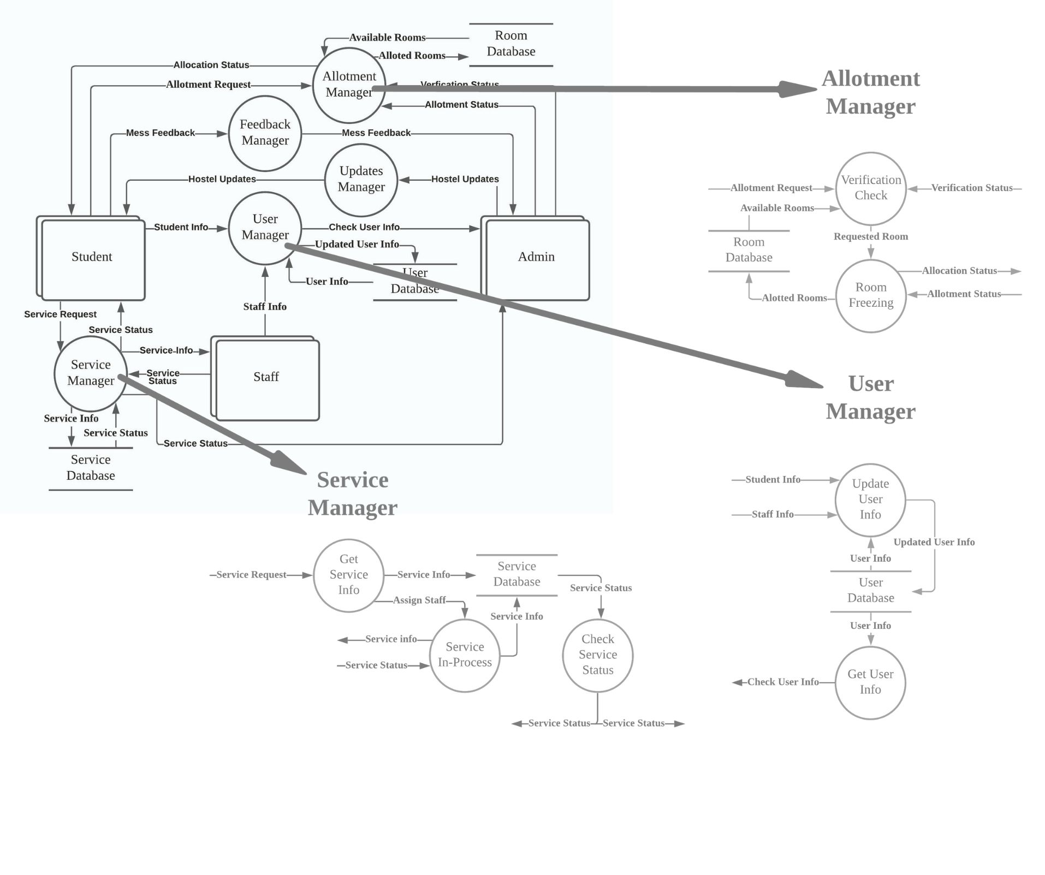

Figure 3.3 DFD Level 2

2.4 Software Requirement Specification in IEEE Format

**Software Requirements** **Specification**

**for**

**Hostel Management System**

**Version 2.0 approved**

**Prepared by**

**Aviral Batra                       102083032**

**Shashwat Garg                       101903483**

**Prabhnoor Kaur                       101903089**

**Thapar Institute Of Engineering And Technology**

**Date: 1st October 2021**

**Table of Contents**

**Table of Contents**........................................................................... ii

**Revision History**............................................................................. ii

1.      **Introduction..**............................................................................ 1

1.1     Purpose.................................................................................. 1

1.2     Document Conventions........................................................... 1

1.3     Intended Audience and Reading Suggestions........................... 1

1.4     Project Scope.......................................................................... 1

1.5     References.............................................................................. 2

2.  **Overall Description**.................................................................. 3

2.1     Product Perspective................................................................. 3

2.2     Product Features..................................................................... 3

2.3     User Classes and Characteristics.............................................. 4

2.4     Operating Environment........................................................... 5

2.5     Design and Implementation Constraints.................................... 5

2.6     Assumptions and Dependencies............................................... 5

3.  **System Features**........................................................................ 6

3.1     Room Allocation.................................................................... 6

3.2     Services/Complaints................................................... 6

3.3     Mess Feedback................................................... 7

4.  **External Interface Requirements**........................................... 8

4.1     User Interfaces........................................................................ 8

4.2     Hardware Interfaces................................................................ 9

4.3     Software Interfaces................................................................. 9

5.  **Other Non-functional Requirements**....................................... 9

5.1     Performance Requirements...................................................... 9

5.2     Safety Requirements............................................................... 9

5.3     Security Requirements............................................................ 10

5.4     Software Quality Attributes..................................................... 10

6.  **Other Requirements**................................................................. 10

Appendix A: Glossary.................................................................... 11

Appendix B: Analysis Models....................................................... 12

**Revision History**

|  |  |  |  |
| --- | --- | --- | --- |
| **Name** | **Date** | **Reason For Changes** | **Version** |
| First Edit | 12/10/21 |  |  |
| Final Edit | 8/12/21 |  |  |

**1.**     **Introduction**

**1.1** **Purpose**

The purpose of this SRS document is to provide a detailed overview of our software product, its parameters and goals. This document describes the project's target audience and its user interface, hardware and software requirements. It defines how our client, team and audience see the product and its functionality.

**1.2** **Document Conventions**

Following typing, Conventions are followed.

* 1.0 line spacing should be used for typing the general text.
* The general text shall be justified and typed in the Font style Arial and Font size 12.
* Heading shall be typed in the Font style 'Arial' and Font size 16 and bold. Subheadings shall be typed in the Font style 'Arial' and Font size 14 and bold.
* Fancy fonts should be avoided for text writing.

**1.3** **Intended Audience and Reading Suggestions**

This Software Requirements Specification is primarily intended for all project developers associated with this project. Users, testers, and other interested parties can also use this document to understand the software better. This Specification is organised into several sections that can be read and referenced as needed.

The project is being designed for the students of Thapar Institute of Engineering & Technology. The students face a lot of problems while staying in their hostels. Thus, we want to automate the entire hostel management so that they can enjoy staying at hostels.

**1.4** **Project Scope**

The goal is to design robust software for managing hostels in Thapar Institute of Engineering & Technology. In the project, we will fully automate most of the work of the hostels' management. These range from selecting one's room online to requesting to get their room cleaned in any campus hostel, a notification will be sent to the housekeeping staff, and the staff employee will go and clean the room at the time mentioned in the request. If a student faces a problem related to electrical works in the room, a notification will be sent to the hostel electrician department. The electrician will reach the room at the mutually accepted time. The complaints regarding carpentry works, plumbing issues and AC repairs will be catered similarly. The students will be asked to fill in the feedback after the work is completed. The students can also give mess feedback and suggestions via an appropriate form. The software must be able to perform the following operations:

1. **Room Allocation**: Students will be able to select their preferred rooms in the allocated Hostel at their comfort level from anywhere without standing for hours in a queue.
2. **Services**: It must notify the respective staff about the request, i.e. if a student wants his room to be cleaned, the staff should get the request, and a person is allotted to do that task.
3. **Complaints**:  It must be able to take complaints from the students in the hostel about the type of work required, i.e. plumbing, carpentering, AC repair etc.
4. **Mess Feedback**: It must take student feedback via form, including questions about taste, hygiene, etc. It should also be able to take suggestions from the students on improving the mess food and menu and send this data to the mess manager.

Initially, the scope of this project will be limited to just Thapar Institute of Engineering & Technology.

But the scope of this project will not be limited to the Thapar Institute of Engineering & Technology campus only as the exact mechanism can be reused in other campuses. There is an uncountable number of institutes in the country where automation of the hostels is required so that students can enjoy their stay at hostels. This system can also be implemented in big cities where service apartments are pretty standard.

**1.5** **References**

* IEEE SRS Format Std 830-1998
* Software Engineering by Ian Sommerville

**2.** **Overall Description**

**2.1** **Product Perspective**

The product will run as a website wherein when the concerned person opens the website's home page, and the person will be asked to log in. Admin, Itself will create the user. Once they log in, a prompt will appear. They will have Multiple Options, including Selecting a Room, Housekeeping, electrical maintenance, AC repair, carpentry work, plumbing issue, mess feedback, and others. In-room selection, you can Select a room of your choice. For Housekeeping, you can send the request with the desired time, cleaning Staff will be allocated. In the Complaint, a box will appear where the student can type the Complaint by selecting the type of Complaint. The notification will go to the Admin as well as concerned Staff.

We will create a well-integrated portal for the management of hostel and mess. Since the incumbent hostel system lacks enough interaction between students and the administration, our priority will be to increase the interaction between all the project stakeholders. On our website, students can request to clean the room at a particular time. The request will go to the housekeeping staff, and a worker will be assigned, and the room will be cleaned on the day the request is made, subject to availability of Staff or the very next day on priority. When an electrical or carpentry complaint is registered, all the complaints will reach the maintenance staff. The electrician or carpenter will get to the room of the complainant to address the problem at the mutually decided time as sometimes students are not present in their room. If the task is not completed in the scheduled time, it will be added to the pending list and done on priority. Once the task initiated by students is complete, the students will be asked to give feedback about the work done by the Staff and make any complaint if there is any. In the case of mess feedback, all the feedbacks received from the students will be carefully monitored by the mess manager.

**2.2**    **Product Features**

The product should be able to perform the following operation:

* It must authenticate the login id for the students residing in the hostels only and for the staff.
* It must initiate requests by the user in the various categories mentioned in Software Requirements Specification for Hostel Management System such as room selection, Complaints, Cleaning, Mess Feedback, etc.
* It must notify the requests made by the user to the respective departments correctly without errors and mixing up.
* It must be able to take the feedback from the students once the task is completed and be able to take the mess feedback.

**2.3** **User Classes and Characteristics**

There are three kinds of users for the proposed system.

* Administrator/Caretaker
* Student
* Staff

**Administrator/Caretaker**

An administrator is the one who monitors all users and user transactions. Admin has to maintain the data of every student profile in the database. When the request is given by the user, the admin checks the availability of the user account, it then is forwarded to the student database. Admin has the complete information related to every student database and all the information related to the students. All the data is maintained and managed at the Admin level. Admin has the right to restrict any database. Admin will monitor all the Complaints, Requests and Room Allocation.

**Student**

Every student who has a room in the hostel has a database and a student account to access his Data. These permissions shall be shown after administrator approval. Students can check his data whether and if it needs any changes. The students can then select the room of their choice at the time of allocation, request housekeeping services and register complaints. They can also check the monthly reports of their fines, mess bills and other stuff.

**Staff**

Staff will be of Different categories. Housekeeping Staff will be able to see all the Housekeeping requests assigned to them from the requests made by students.

Other Staff that includes carpenters, plumbers, electricians etc., will be able to see all the complaints assigned to them. They can respond to requests and complaints as done or resolved. They can check their data and change their profile.

**2.4** **Operating Environment**

The HMS is a Python and JavaScript-based application. The user will use this application to maintain the database of students & the rooms, mess. The application of Hostel Management System has a very user-friendly interface. The software provides accuracy and a pleasant interface, Make the present manual system more interactive, speedy and user friendly.

**2.5** **Design and Implementation Constraints**

The development of the system will be constrained by the availability of required software such as web servers, databases and development tools. The availability of these tools will be governed by the Thapar Institute of Engineering & Technology. The hardware constraints include a smartphone or laptop to access the website and make the request.

**2.6**    **Assumptions and Dependencies**

The following list prevents the assumptions, dependencies or guidelines that are imposed upon implementation of the System:

* The product must have a user-friendly interface that is simple enough for all types of users to understand.
* Response time should not be longer than a few seconds.
* General knowledge of basic computer skills and the internet is required to use the product.
* Admin Will be created directly in the Database.
* Admin Beforehand will create staff and Students Login
* Roles and Tasks are Predefined

**3.**     **System Features**

These are Some of the Major System Features that our Software has to Offer

**3.1**   **Room Allocation**

**3.1.1**           **Description and Priority**

This is one of the most valuable features our software has to offer. This can help improve the failed Room allocation system, reduce long queues, and smooth the Process by Allocating the rooms online and of their choice.

**3.1.2**           **Stimulus/Response Sequences**

Firstly, the User will log in to his account and be shown the Hostel allocated to him. Then, the software will tell if the documents are verified or not; once the Documents are verified, the user will have the facility to choose their room from the options available. The room will be allotted based on FCFS

**3.1.3           Functional Requirements**

**REQ-1:** Student(): The User must be a Student of that College having valid Roll No.

**REQ-2:** System(): The User must have working System either a SmartPhone or Laptop

**REQ-3:** Verified(): The User Documents must be verified before he can select a room

**3.2**    **Services & Complaints**

**3.2.1**           **Description and Priority**

This feature will allow users to request a Housekeeping Service or Register a complaint from their room only by giving their preferred time. Also, on the Other hand, the staff will be able to see the service and complaint allotted to them with room no. with options of Done or Resolved.

**3.2.2**           **Stimulus/Response Sequences**

Firstly User will log in to their account and must have a room allocated to them. Then the user can request a Housekeeping service with their preferred time or register a Complaint mentioning the type of complaint and preferred time. Then the Staff will get a Notification with the work and room allotted to them and at what time. After completing the work, the staff can respond with Done or "Resolved". After that, the student will also have the option to respond as pending or Done/Resolved. Agreement from both sides will close the request or a complaint.

**3.2.3           Functional Requirements**

**REQ-1:** Student(): The User must be a Student of that College having valid Roll No.

**REQ-2:** System(): The User must have working System either a SmartPhone or Laptop

**REQ-3:** Verified(): The User Documents must be verified before he can select a room

**REQ-4:** Staff(): The Staff must have an Account on our Software

**3.3**    **Mess Feedback**

**3.3.1**           **Description and Priority**

This feature will allow users to give Feedback on the Mess food of that particular day and send that feedback to the Mess Manager.

**3.3.2**           **Stimulus/Response Sequences**

Firstly, the user will log in to their account and be a resident and have a room allocated to them. The User will then have the option to Give Feedback.

**3.3.3           Functional Requirements**

**REQ-1:** Student(): The User must be a Student of that College having valid Roll No.

**REQ-2:** System(): The User must have working System either a SmartPhone or Laptop

**REQ-3:** Verified(): The User Documents must be verified before he can select a room

**REQ-4:** Staff(): The Staff must have an Account on our Software

**4.**    **External Interface Requirements**

**4.1** **User Interfaces**

There are three kinds of user Interface for the proposed system.

* Administrator/Caretaker Interface
* Student Interface
* Staff Interface

Our goal is to develop software that should be easy to use for all types of users. Thus while designing the software, one can assume that each user type has the following characteristics:

* The user is computer-literate and has little or no difficulty using the software, keeping in mind the software is user friendly.
* A user must be aware of the internal working and know how things work to use the software.
* All the guidelines about the use of the software will be informed to the user once the user signs up on the software or web page.

These interfaces will be variated according to Hostel & Student detail requirements. However, they will have some common properties such as:

* A customisable window
* Menus & Maps
* Account Info

**Additional Features**

* Student Interface will have an additional Feature to select a room, register complaints and services.
* Staff Interface will have an additional feature to see services and complaint requests assigned to them and the option of done/resolved.

**4.2** **Hardware Interfaces**

* **Computer**: A computer will be required to open the website and use the software
* **Smartphone**: A smartphone can also be required in case there is no availability of computers.
* **Internet**: A good internet connection is required to access the website.
  1. **Software Interfaces**
* A SQL Database Server will be required to store and retrieve data.
* A web browser will be required to open the website.

**5.** **Other Non-functional Requirements**

**5.1** **Performance Requirements**

* The application shall be based on Python and JavaScript and has to be run on any platform.
* The application shall take an initial load time depending on the performance of the Operating System.
* The performance shall depend upon the hardware & software components of the computer.

**5.2** **Safety Requirements**

The project shall provide storage of all databases on redundant computers with some database software.

**5.3**    **Security Requirements**

* This project provides genuine security to all those individuals who have their accounts on the database as they are password protected.
* This is a crucial aspect of the design and should cover hardware reliability, fallback procedures, physical security of data and provision for detection of fraud and abuse.

**5.4**    **Software Quality Attributes**

**Maintainability**

Hostel Management System will be maintainable as long as there are no Hardware & software problems. Also, databases should be updated.

**Portability**

The project is made in JavaScript as frontend & SQL database and Django as back end and will work upon all OS efficiently.

**6.**     **Other Requirements**

* Provide rating after request completion.
* Select an available time slot for response to the issue.
* Get predefined fields of the question for better characterising the main problem area.

**Appendix A: Glossary**

* **IEEE** – Institute of Electrical and Electronics Engineers
* **RSA** – Rational Software Architect
* **UML** – Unified Modelling Language
* **DFD** – Data Flow Diagram
* **HMS** - Hostel Management System
* **User**: The student who lives in the hostel.
* **Admin**: The warden of the hostel who manages all the things.
* **ID card:** The card issued by the hostel/college and contains information about the student.
* **Database**: Records of every current and old student is saved here.
* **Account number:** The HMS issues this when the new students become a part of the hostel. This number is on the ID card of the student. This is the user's ID.
* **Mess status:** It tells the mess information of the students.

3. Design Phase

3.1 Class Diagram

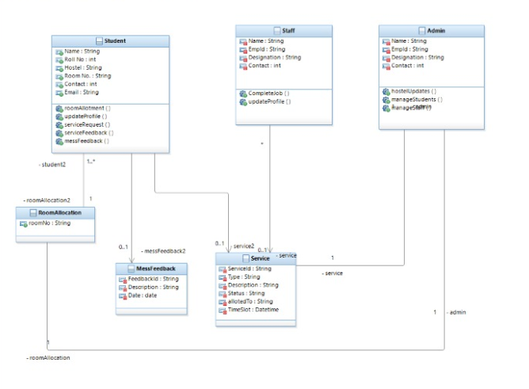

Figure 4: Class diagram

Figure 4 shows the class diagram for our Hostel Management System. Class diagram is the static structure diagram that describes the structure of a system by showing the system's classes, their attributes, operations, and the relationships among objects. Class diagrams for login, student, admin, job opening and eligibility are made, and different operations corresponding to them are displayed along with the attributes these classes possess.

3.2 Sequence Diagram

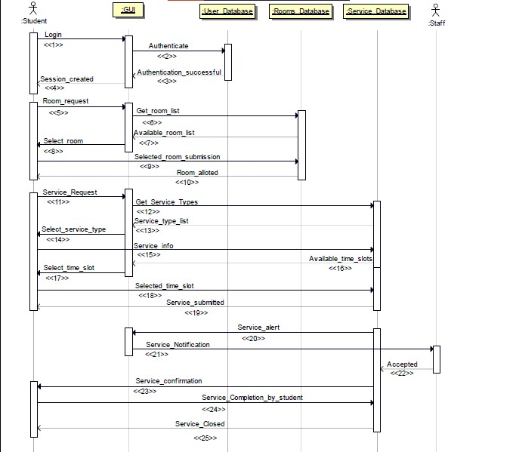

Figure 5: Sequence Diagram

Figure 5.1 shows the sequence diagram for the HMS. Sequence diagram shows the interactions between the objects in a timely sequence manner. In both cases, the first operation is login. When a user/admin logs in on the portal, a request goes to the server for authentication, which is approved by verifying the credentials in the database. The same needs to be done by the admin to access the HMS module. The message flow between the various objects is shown in a timely sequence using this diagram.

3.3 Collaboration Diagram

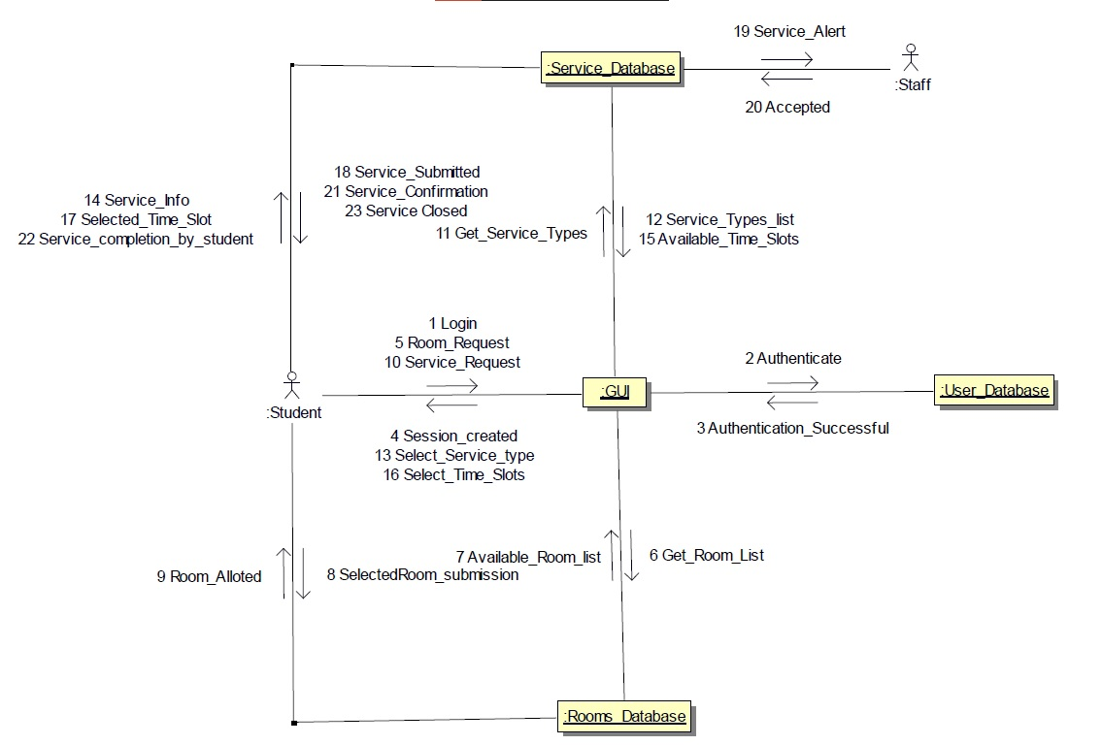

Figure 6: Collaboration Diagram

Figure 6 shows the collaboration diagram for HMS. A collaboration diagram is an illustration of the relationships and interactions among software objects in the Unified Modeling Language (UML).

State Chart Diagram

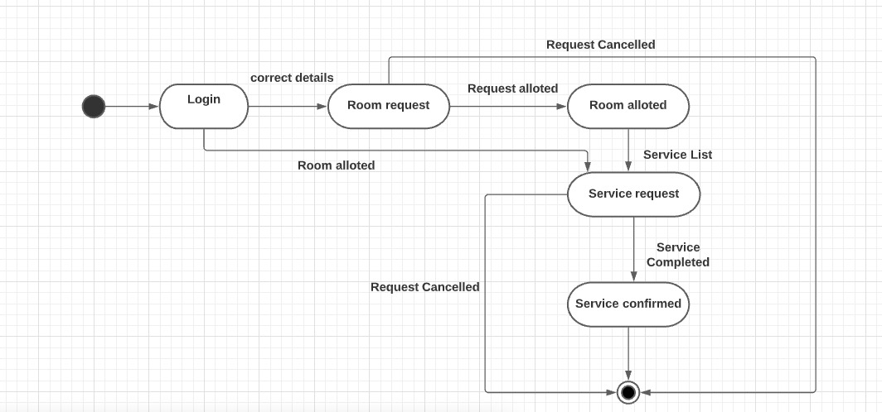

Figure 7 State Chart Diagram

Figure 7 models the dynamic behaviour of individual classes or any other kind of objects. They show the sequence of states that an object goes through, the events that causes a transition from one state to another and the actions that result from a state change. It is typically used to model the discrete stages of an object's lifetime. It typically contains one state chart and multiple end states and transitions connected to various states on the diagram

Component Diagram

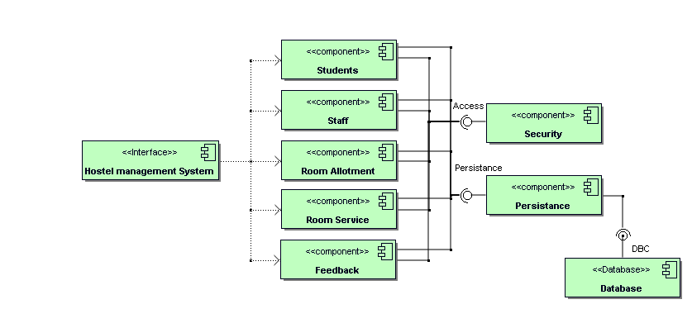

Figure 9: Component Diagram

Figure 9 breaks down the complete object-oriented system into components and represents the components used to make functionalities. It is a special kind of UML diagram with the main purpose of envisioning all the components used in the system and depicting the relationship and organization among all the components of the system.

Deployment Diagram

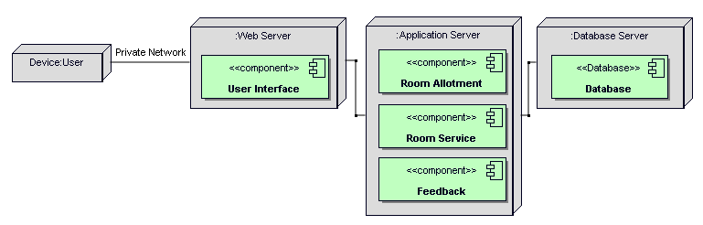

Figure 10: Deployment Diagram

Figure 10 is a deployment diagram which is a special kind of UML model, which shows the configuration of run-time processing nodes and the components used in the system. The main purpose of the deployment diagram is to understand the run-time configuration and see how the hardware used is linked to each other and the communication paths between them.

4. Prototyping-GUIs

4.1 Screen Shots

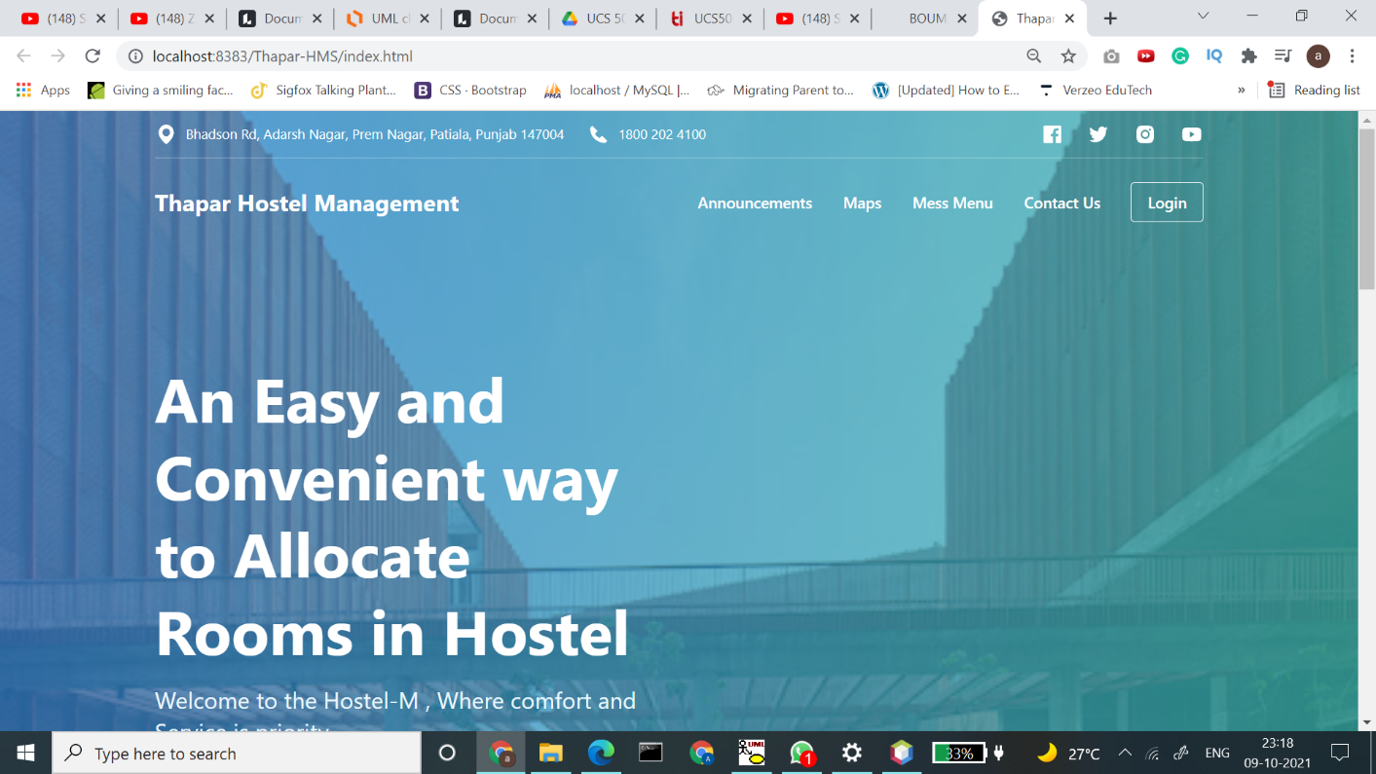

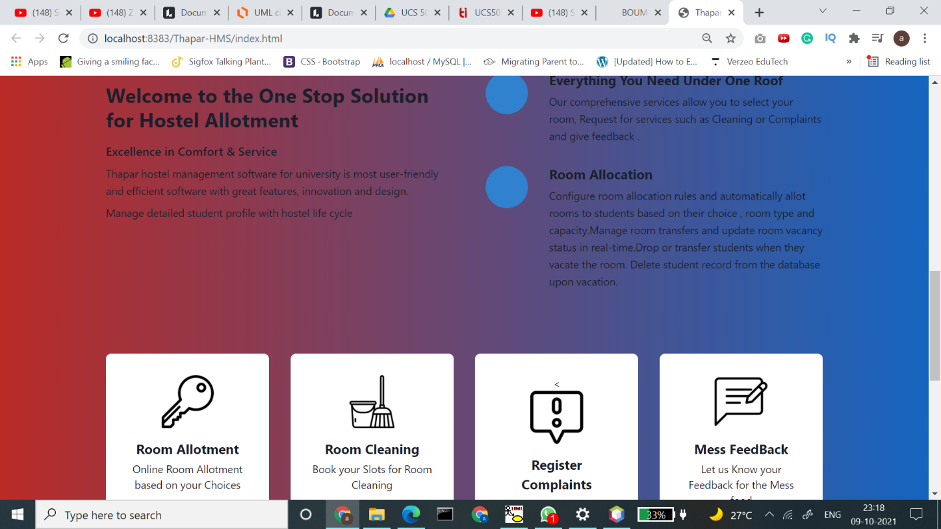

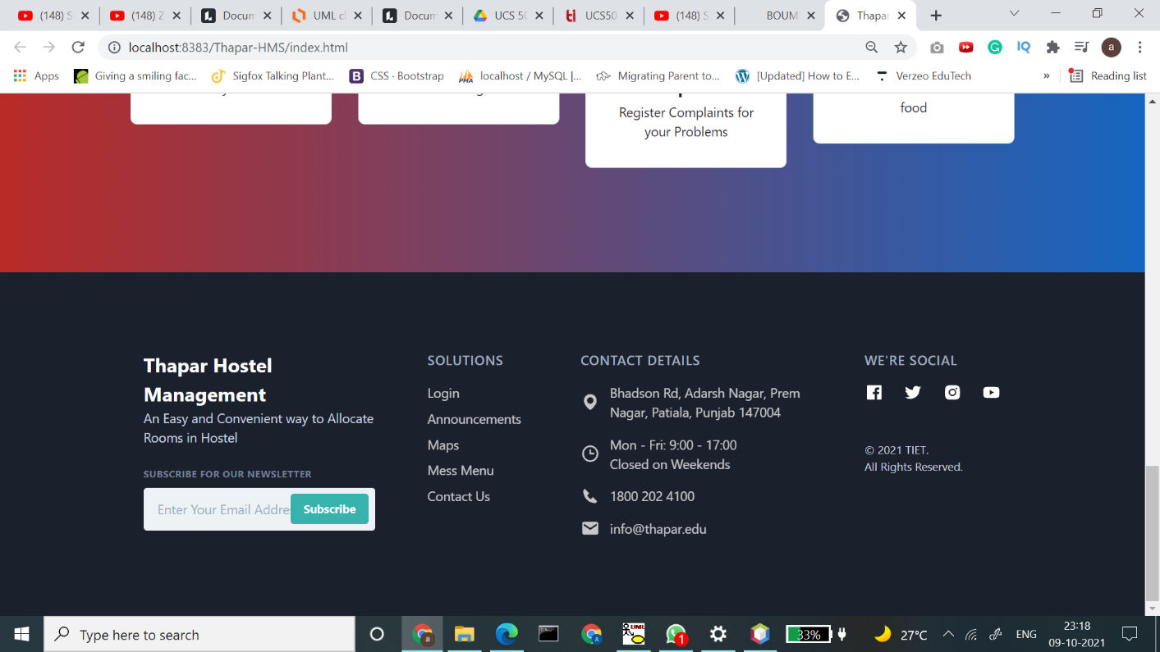

Figure 11: Home Page

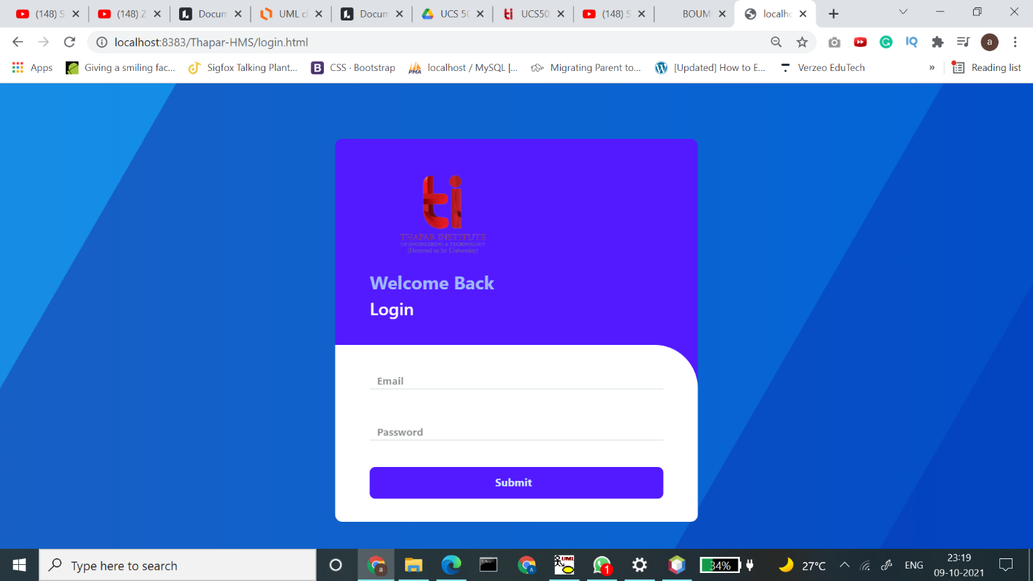

Figure 12: Login Page

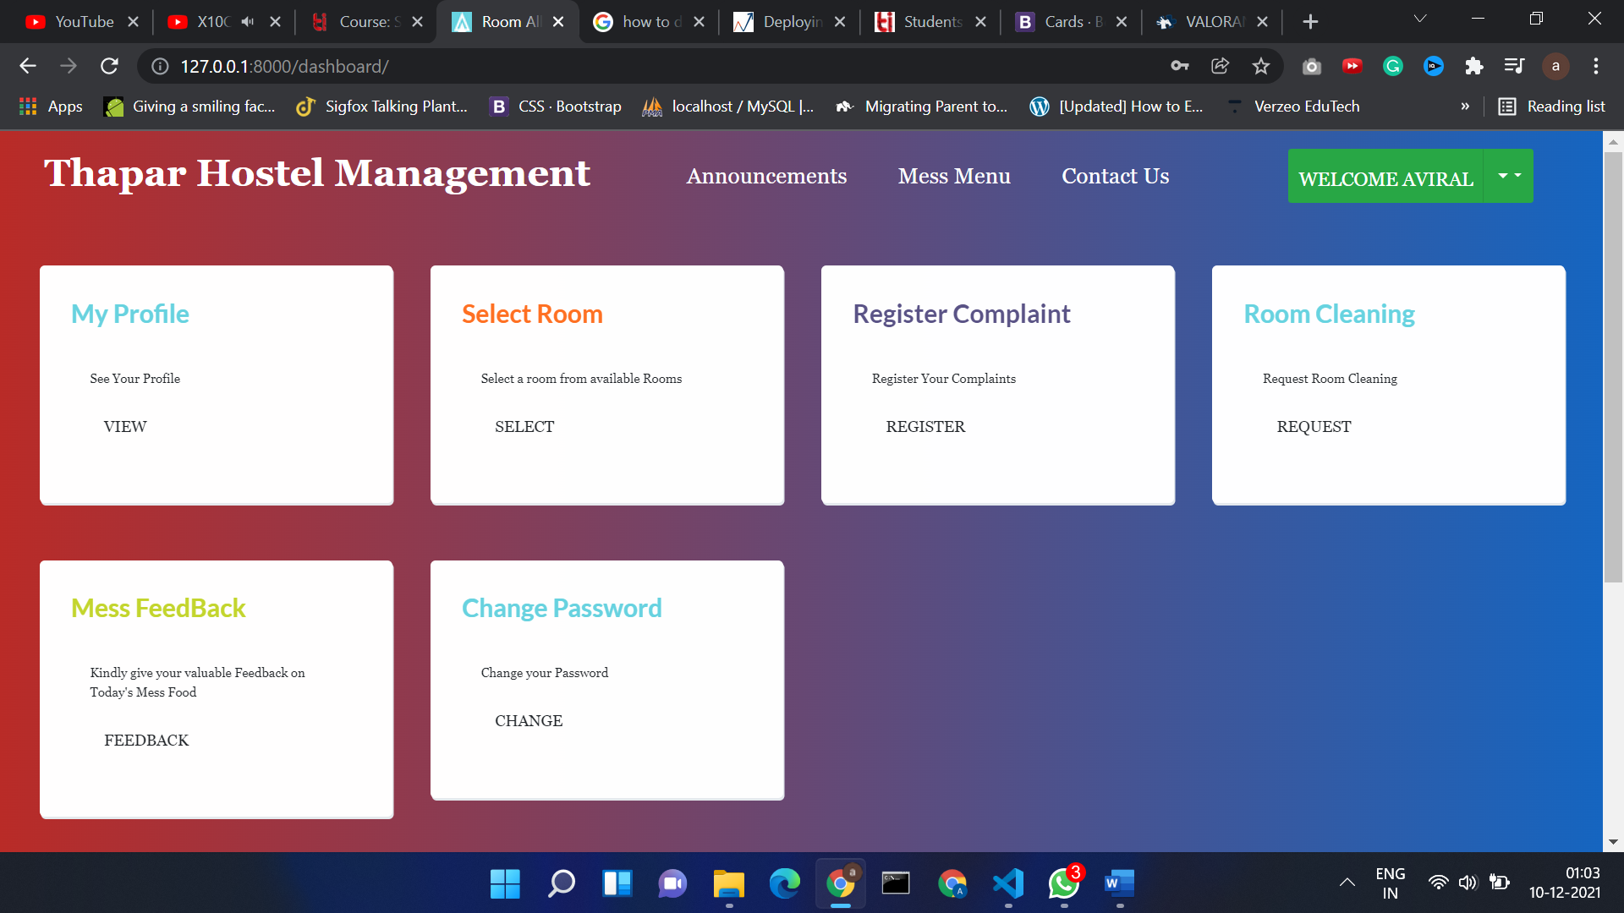

Figure 13: Dashboard

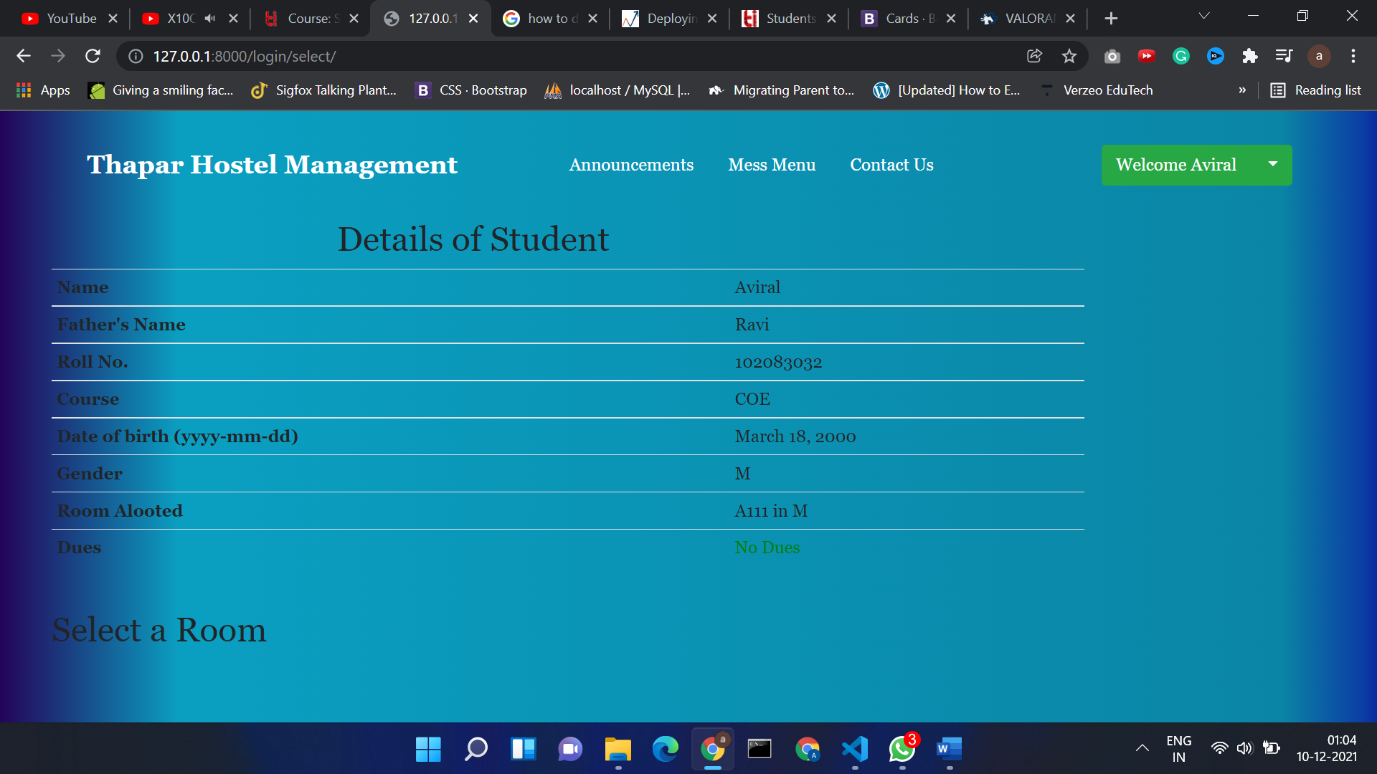

Figure 14: Student Profile

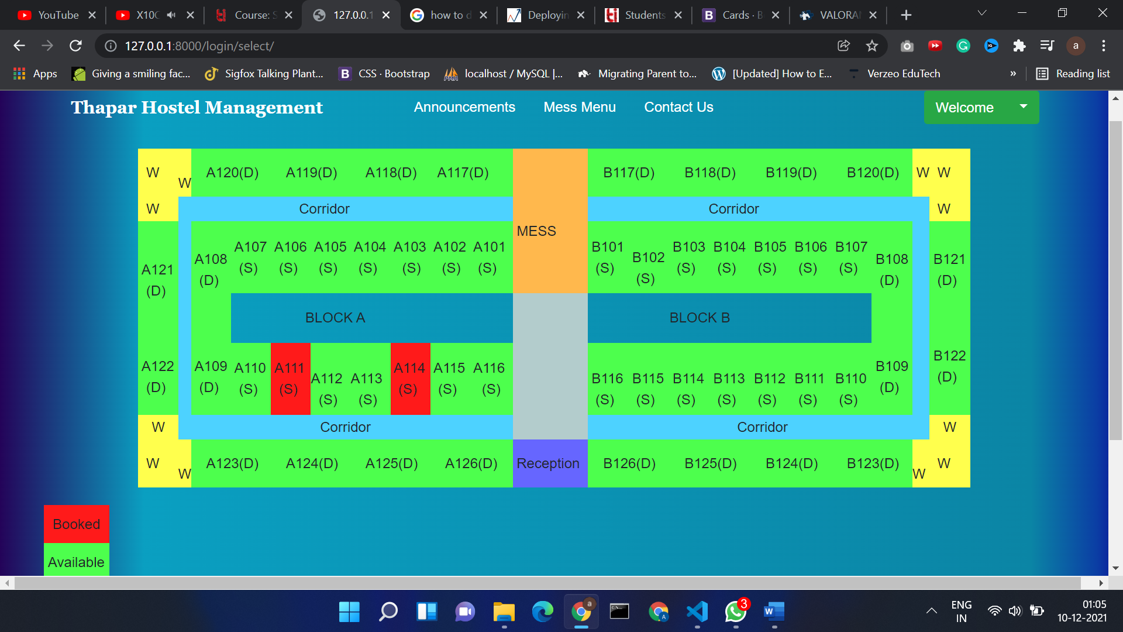

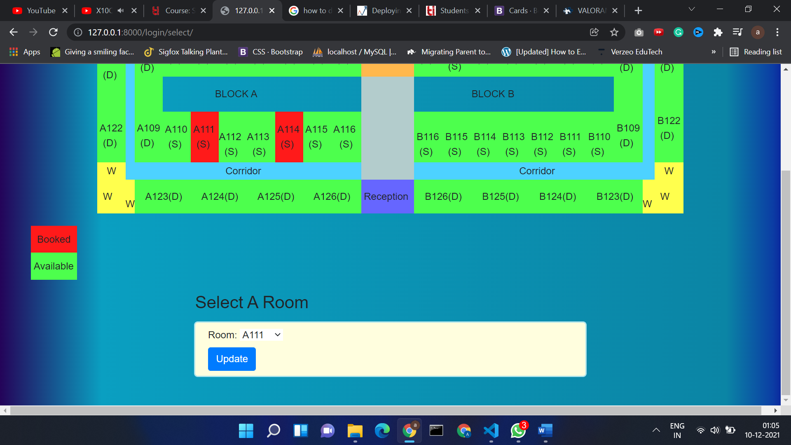

Figure 15: Available Rooms and Select Room Page

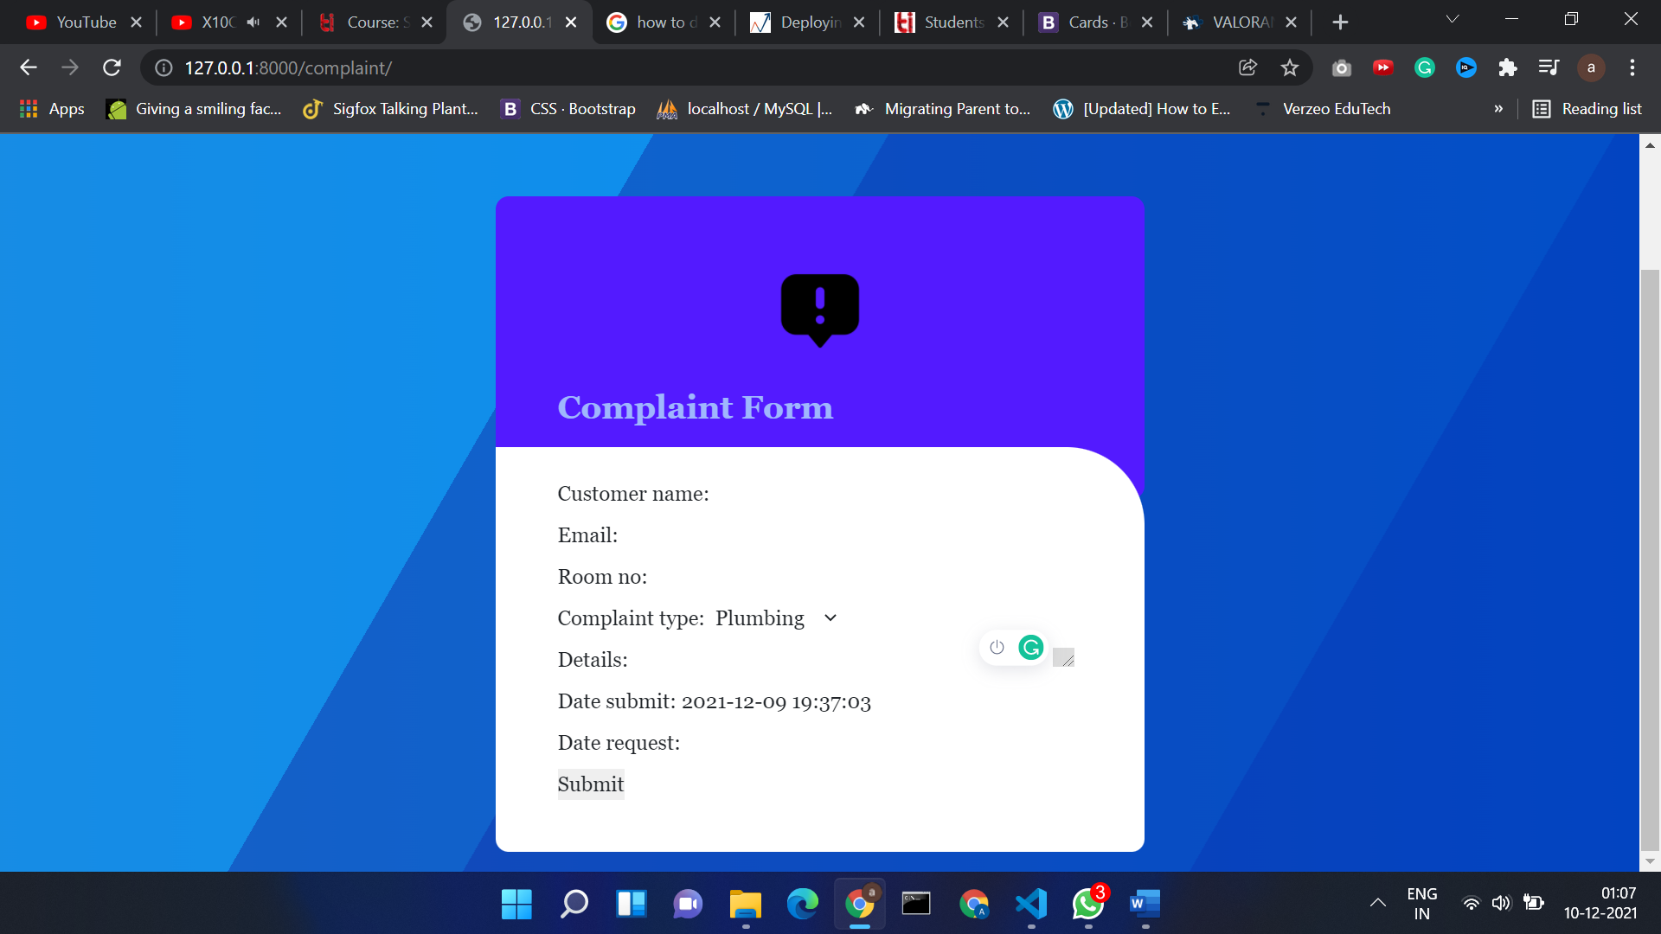

Figure 16: Complaint Page

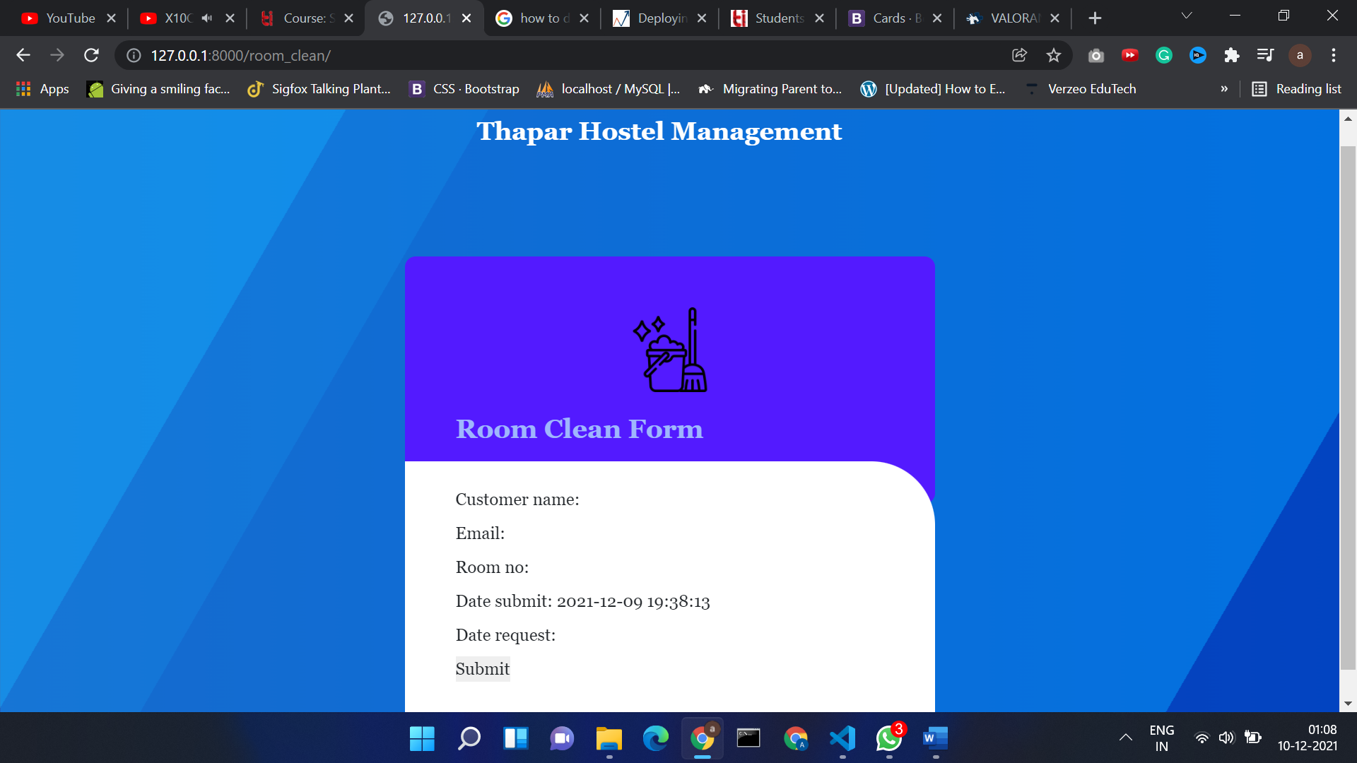

Figure 17: Room Cleaning Form

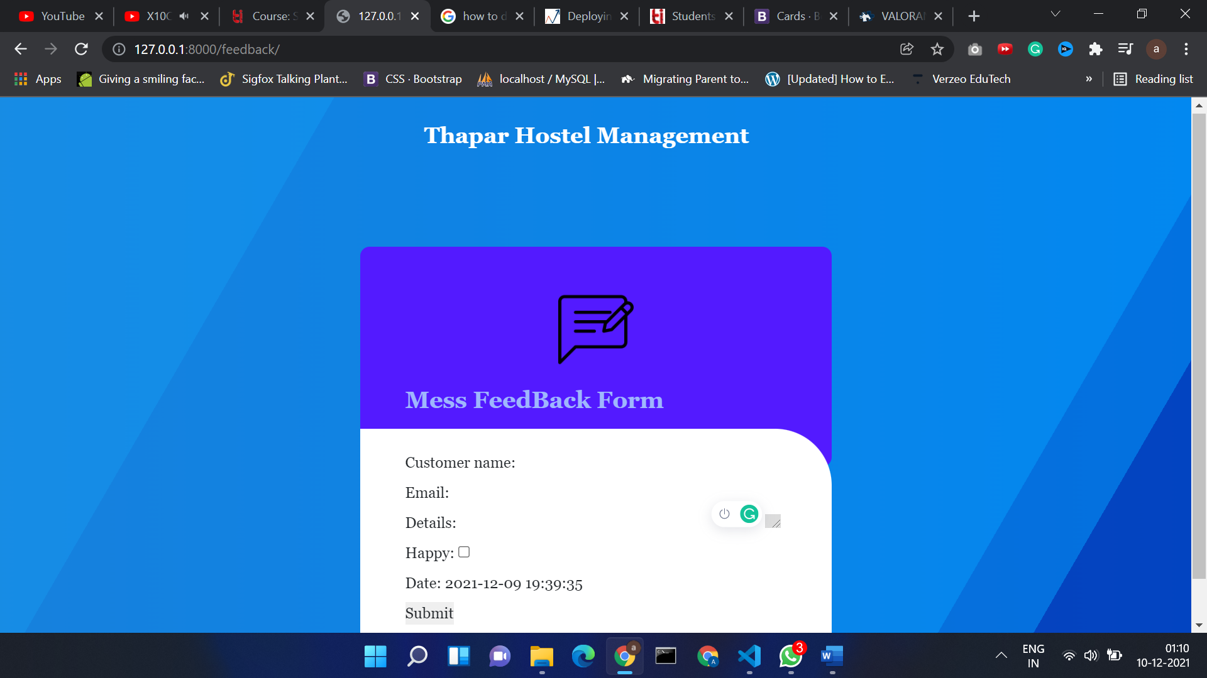

Figure 18: Mess Feedback Form

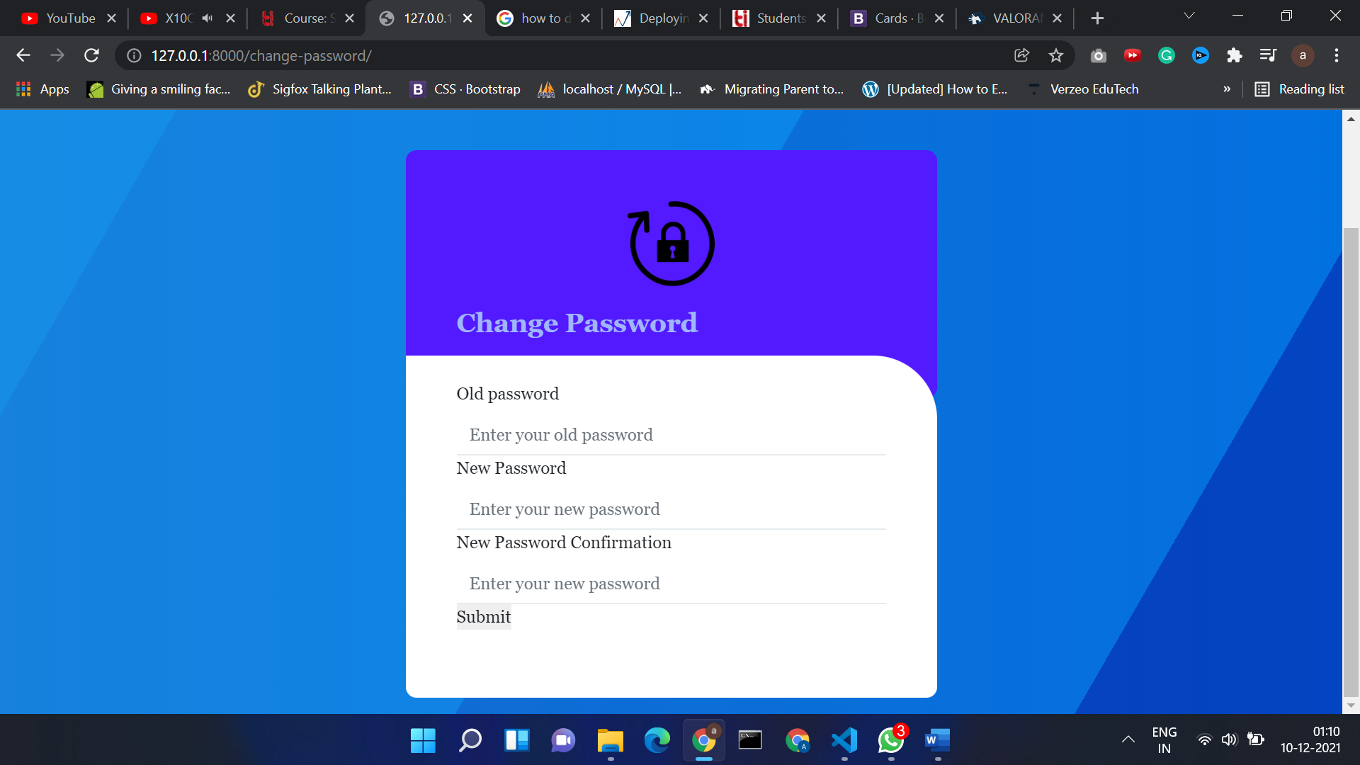

Figure 19: Change Password Form

5. Testing

**Test Case 1**

**Test Case #: 1.1**

**System: Hostel Management**

**Designed by:Aviral,Shashwat,Prabhnoor**

**Executed by: Aviral**

**Short Description: Test the Login System**

**Test Case Name:Login**

**Subsystem: Login**

**Design Date:05-12-2021**

**Execution Date: 09-12-2021**

**Page: 1 of 7**

**Pre-conditions**

1. **Student must have a valid username and password**
2. **Student must have a valid college ID Proof**

|  |  |  |  |  |
| --- | --- | --- | --- | --- |
| **Step** | **Action** | **Expected System Response** | **Pass/ Fail** | **Comment** |
| 1 | Click the Login Button | System displays login Page |  |  |
| 2 | User enters correct username avi and password django | System checks the username and password in the database and after successful login redirects to dashboard | Pass |  |

**Post-conditions**

1. **User is redirected to the Personal Dashboard where it can access various utilities that system offer like room allocation , feedback etc.**

Test Case 2

**Test Case #: 1.2**

**System: Hostel Management**

**Designed by:Aviral,Shashwat,Prabhnoor**

**Executed by: Aviral**

**Short Description: Test the Login System**

**Test Case Name:Login**

**Subsystem: Login**

**Design Date:05-12-2021**

**Execution Date: 09-12-2021**

**Page: 2 of 7**

**Pre-conditions**

1. **Student must have a valid username and password**
2. **Student must have a valid college ID Proof**

|  |  |  |  |  |
| --- | --- | --- | --- | --- |
| **Step** | **Action** | **Expected System Response** | **Pass/ Fail** | **Comment** |
| 1 | Click the Login Button | System displays login Page |  |  |
| 2. | User enters incorrect username avi and password 12345 | System checks the username and password in the database and after unsuccessful login shows the error message | Pass |  |

**Post-conditions**

1. **User is asked to enter the credentials again for successful Login**

**Test Case 3**

**Test Case #: 2.1**

**System: Hostel Management**

**Designed by:Aviral,Shashwat,Prabhnoor**

**Executed by: Aviral**

**Short Description: Test the Room Allocation system**

**Test Case Name:Room Allocation**

**Subsystem: Select a room**

**Design Date:06-12-2021**

**Execution Date: 09-12-2021**

**Page: 3 of 7**

**Pre-conditions**

1. **Student must have a valid username and password**
2. **Student must be Logged into the system to select room**

|  |  |  |  |  |
| --- | --- | --- | --- | --- |
| **Step** | **Action** | **Expected System Response** | **Pass/ Fail** | **Comment** |
| 1 | Click the Select Room Button | System displays select room page and available rooms |  |  |
| 2. | User selects the room from the available rooms – A112 | System shows the personal details along with allotted room | Pass |  |
| 3. | User selects the room from the allotted rooms -A111 | System shows the error and ask to select again |  |  |

**Post-conditions**

1. **User Selected Room A112 is stored in the student database and selected room is stored as allotted in room database**

**Test Case 4**

**Test Case #: 3.1**

**System: Hostel Management**

**Designed by:Aviral,Shashwat,Prabhnoor**

**Executed by: Aviral**

**Short Description: Test the Feedback Form**

**Test Case Name: Feedback Form**

**Subsystem: Give Feedback**

**Design Date:06-12-2021**

**Execution Date: 09-12-2021**

**Page: 4 of 7**

**Pre-conditions**

1. **Student must have a valid username and password**
2. **Student must be Logged into the system to Give Feedback**

|  |  |  |  |  |
| --- | --- | --- | --- | --- |
| **Step** | **Action** | **Expected System Response** | **Pass/ Fail** | **Comment** |
| 1 | Click the Give Feedback Button | System displays the Feedback Form |  |  |
| 2. | Student Enters the details asked in Feedback Form | System shows the “Thanks for your feedback “ Message | Pass |  |

**Post-conditions**

1. **Student Feedback is stored in the feedback database**

**Test Case 5**

**Test Case #: 4.1**

**System: Hostel Management**

**Designed by:Aviral,Shashwat,Prabhnoor**

**Executed by: Aviral**

**Short Description: Test the Change Password System**

**Test Case Name: Change Password**

**Subsystem: Change Password**

**Design Date:07-12-2021**

**Execution Date: 09-12-2021**

**Page: 5 of 7**

**Pre-conditions**

1. **Student must have a valid username and password**
2. **Student must be Logged into the system to Change Password**

|  |  |  |  |  |
| --- | --- | --- | --- | --- |
| **Step** | **Action** | **Expected System Response** | **Pass/ Fail** | **Comment** |
| 1 | Click the Change Password Button | System displays the Change Password Form |  |  |
| 2. | Student Enters the correct old password | System checks if old password is correct the asks  For new password | Pass |  |
| 3. | Student Enters new password | System checks if new password satisfy all conditions then asks to reenter new password |  |  |
| 4. | Student Reenters correct new password | System checks if both the password entered are same  Then shows success message |  |  |

**Post-conditions**

1. **Student New Password 12345 is saved in student database**

**Test Case 6**

**Test Case #: 4.2**

**System: Hostel Management**

**Designed by:Aviral,Shashwat,Prabhnoor**

**Executed by: Aviral**

**Short Description: Test the Change Password System**

**Test Case Name: Change Password**

**Subsystem: Change Password**

**Design Date:07-12-2021**

**Execution Date: 09-12-2021**

**Page: 6 of 7**

**Pre-conditions**

1. **Student must have a valid username and password**
2. **Student must be Logged into the system to Change Password**

|  |  |  |  |  |
| --- | --- | --- | --- | --- |
| **Step** | **Action** | **Expected System Response** | **Pass/ Fail** | **Comment** |
| 1 | Click the Change Password Button | System displays the Change Password Form |  |  |
| 2. | Student Enters the wrong old password | System checks if old password is correct then gives the error message of wrong password | Pass |  |
| 3. | Student Enters the correct old password | System checks if old password is correct the asks  For new password |  |  |
| 4. | Student Enters invalid new password | System checks if new password satisfy all conditions then gives error message that password does not match conditions |  |  |
| 5. | Student Enters valid new password | System checks if new password satisfy all conditions then asks to reenter new password |  |  |
| 6. | Student Reenters correct new password | System checks if both the password entered are same  Then shows success message |  |  |

**Post-conditions**

1. **Student New Password 12345 is saved in student database**

**Test Case 7**

**Test Case #: 5.1**

**System: Hostel Management**

**Designed by:Aviral,Shashwat,Prabhnoor**

**Executed by: Aviral**

**Short Description: Test the Logout System**

**Test Case Name: Logout**

**Subsystem: Logout**

**Design Date:07-12-2021**

**Execution Date: 09-12-2021**

**Page: 7 of 7**

**Pre-conditions**

1. **Student must have a valid username and password**
2. **Student must be Logged into the system to Logout**

|  |  |  |  |  |
| --- | --- | --- | --- | --- |
| **Step** | **Action** | **Expected System Response** | **Pass/ Fail** | **Comment** |
| 1 | Click the Logout Button | System displays the Message Successful Logout  System clears all the session details | Pass |  |

**Post-conditions**

1. **Student is successfully Logged Out and redirected to home**